VIETNAM NATIONAL UNIVERSITY – HOCHIMINH CITY
THE INTERNATIONAL UNIVERSITY
SCHOOL OF COMPUTER SCIENCE AND ENGINEERING

THESISBOARD - WEB-BASED MANAGEMENT SYSTEM
FOR PRE-THESIS AND THESIS PROJECTS AT CSE

By
Tran Thien

A bachelor’s pre-thesis submitted to Mr. Le Thanh Son in partial fulfillment of the requirements for the report of Special Study of the Field

Ho Chi Minh city, Vietnam
2025
THESISBOARD - WEB-BASED MANAGEMENT SYSTEM
FOR PRE-THESIS AND THESIS PROJECTS AT CSE

APPROVED BY: ________________________________,
Mr. Le Thanh Son, MSc., Supervisor

DECLARATION OF AUTHORSHIP

Author’s declaration
I firmly declare that this pre-thesis, "ThesisBoard - Web-based Management System for Pre-thesis and Thesis Projects at CSE” is my own original work and has not been submitted previously for any academic degree at this or any other institution.
All sources of information and data used in this pre-thesis have been properly acknowledged and referenced. I understand the university's policy regarding academic integrity and plagiarism.
Author: Trần Thiện
21.06.2025

ACKNOWLEGMENTS

First and foremost, I am really grateful my supervisor, Mr. Le Thanh Son, for his great guidance, and detailed orientations. I cannot believe that I have been able to make it this far journey without his valuable ideas and clear direction. Those supports are likely guiding principles for me so that I can focus and move forward step by step.
I also would like to thank Mr. Nguyen Van Sinh for his engaging lectures on Web Application Development. They gave me a solid foundation and practical knowledge that I could immediately apply when building the system. In addition, I would like to thank Mr. Le Trung Nghia due to his patient support on the fundamentals of web development in detail on the lab sections of Web Application Development so that I can understand everything much more clearly and boosted my confidence in the field.
Most importantly, I would like to thank my parents and my partner for their encouragement and trust, helping me do the daily work and giving me the time and focus needed to finish this project, especially during challenging moments.

TABLE OF CONTENTS

LIST OF FIGURES vii
ABSTRACT viii
CHAPTER I
INTRODUCTION 1
1.1. Background and Motivation 1
1.2. Problem Statement 2
1.3. Objectives 3
CHAPTER II
LITERATURE REVIEW AND METHODOLOGY 4
2.1. Literature Review 4
2.1.1. Related Systems and Solutions 4
2.1.2. Comparison with Proposed System 5
2.1.3. Research Gap 6
2.2. Methodology 6
2.2.1. Software Development Model 6
2.2.2. Requirements Gathering 7
2.2.3. Functional and Non-functional Requirements 7
2.2.4. System Design Approach 8
2.3. Summary 9
CHAPTER III
RESULTS 10
3.1. Overview of the System 10
3.2. Functional Results 10
3.2.1. Student Functions 10
3.2.2. Teacher Functions 14
3.2.3. Moderator/Admin Functions 17
3.3. Database Results 20
3.4. Summary 21
CHAPTER IV
DISCUSSION / IMPLEMENTATION 22
4.1. System Architecture 22
4.2. Implementation Tools and Environment 23
4.3. Backend Implementation 24
4.4. Frontend Implementation 25
4.5. Role-Based Access Control 26
4.6. Integration of Frontend and Backend 26
4.7. Challenges and Solutions 27
4.8. Summary 27
CHAPTER V
CONCLUSION AND RECOMMENDATION 29
5.1. Summary of the Project 29
5.2. Major Findings and Achievements 30
5.3. Limitations 31
5.4. Recommendations for Improvement 32
5.5. Conclusion 32
REFERENCES 33

LIST OF FIGURES

Figure 1. Pre-Thesis Topic List Page 11
Figure 2. Pre-Thesis Registration 12
Figure 3. Thesis students contact teachers for registration 12
Figure 4. File submission form 13
Figure 5. Grades and evaluation 14
Figure 6: Topic creation form for pre-thesis 15
Figure 7. Student aproval table for pre-thesis 16
Figure 8. Thesis assignment form 16
Figure 9. Grading form 17
Figure 10. Deadline panel for semesters 18
Figure 11. Thesis management 19
Figure 12. User ERD 20

ABSTRACT

This pre-thesis presents the design and implementation of a web-based system to support the pre-thesis and thesis process at International University – VNU HCMC. In the current process, students and lecturers in our faculty still manage everything manually using paperwork. This often causes confusion, delays, and makes it hard to track progress. Lecturers can create pre-thesis and thesis with limited slots, and students can register directly through the platform. After that, the system automatically matches students to supervisors — which used to be done manually by email.
The proposed system provides role-based access for four types of users: students, teachers, moderators, and administrators. Key features include topic creation and registration, automatic student-topic matching, report submission, announcement broadcasting, notification and grading. The system was developed using React.js for the frontend, Express.js and Sequelize for the backend, and MySQL as the database management system.
Although the system has not yet been deployed for public use, internal testing confirmed that core workflows and permissions work as intended. This platform helped simplify the pre-thesis and thesis process for both students and lecturers — especially when handling report submissions and announcements.
In the future, I have planned to enhance the system by adding data visualization charts which may show out diverse statistics such as pre-thesis and thesis quantities, overall grades or completed rates. I also want the system to be able to have audit logging, more useful configurations, so that the system can be maintained without changing source code much. Another key point is that I want to enhance the system to allow customization of roles and permissions - instead of the fixed role-based system at current time, the system then allows administrators to create and manage roles and permissions dynamically based on their demand.

CHAPTER I

INTRODUCTION

- Background and Motivation
The idea of “ThesisBoard - Web-based Management System for Pre-thesis and Thesis Projects at CSE” is originally stated from proposal to build a highly applicable system to streamline and improve the management of pre-thesis and thesis dissertation activities. The motivation came from thinking of a unified system to facilitate the coordination between students, teachers, and faculty staff in the management of pre-thesis and thesis dissertation processes. Since it is seemly hard to manage manually.
Currently, the faculty relies on manual and inconsistent methods such as spreadsheets for topic registration and email for communication and document submission. Therefore, not only does this approach waste a significant amount of time, it also leads to inefficiencies, miscommunication, and missed deadlines. Moreover, students are required to email supervisors to register for available topic without real-time updates on availability, which can lead to delays and confusion. In some cases, there are missed registration opportunities due to students’ registration emails accidentally pushed to spam folder. Furthermore, faculty have to manually update registration status and generate pre-thesis and thesis dissertation reports, which becomes increasingly difficult as the number of students increases.
This project aims to solve these challenges with a centralized platform where students can register for topics, submit documents, and track their progress. In addition, teachers can manage their students lists, establish and update topic availability, and evaluate student submissions. Faculty staff can manage students, assign committee members or thesis defense dates, generate reports, and configure system settings flexibly. The system aims to enhance interaction and communication between all stakeholders involved in the pre-thesis and thesis process.

- Problem Statement
The CSE department now is lacking a unified, automated system to manage the pre-thesis and thesis process. Existing procedures are manual, fragmented, and inefficient. These issues include but are not limited to topic registration management via email and editable spreadsheets are outdated and not systematic and logical; slow email correspondence between teachers and students; inability to verify supervisor’s remaining slot availability in real-time; students do not have a systematic way to submit materials; faculty staff are challenging when manually creating reports for administrative use; these challenges affect faculty members' ability to oversee the entire process, teachers' ability to successfully manage students, and students' ability to complete registration.
- Objectives
This project's main goal is to establish a web-based management system with various essential features. This system gives teachers the ability to create and manage pre-thesis and thesis topics with limited slots. Another purpose is to allow students to register for topics in pre-thesis, teachers contact information in the thesis, submit reports, and communicate with their supervisors. The system also gives faculty members the means to export dynamic reports and track students' progress. The further aim is to support role-based access for students, lecturers, moderators, and administrators; and promote collaboration and communication between all parties involved.

CHAPTER II

LITERATURE REVIEW AND METHODOLOGY

- Literature Review
- Related Systems and Solutions
Several existing platforms support academic course management, thesis coordination, and student–lecturer interactions. Among them, Moodle and Blackboard are widely recognized learning management systems used by educational institutions worldwide.
Moodle is an open-source platform that allows us to create customizable learning environments. It includes features like course creation, online assessments, discussion forums, and file submission. It supports various user roles, including students, teachers, and administrators. While Moodle is extremely adaptable and extensible, it can be difficult to configure and does not include specific support for thesis workflows such as supervisor assignment or multi-stage report grading.
Blackboard is a commercial system, currently used at International University for academic management, provides enterprise-level learning capabilities such as grading, analytics and course communication. It has a sophisticated UI, wide support, and strong scalability. However, Blackboard is pricey and its closed-source design limits customization. Also, it is geared for general course delivery rather than pre-thesis or thesis process management.
In summary, both Moodle and Blackboard systems provide great academic support capabilities but are not designed to address the special needs of thesis and pre-thesis coordination in a Computer Science and Engineering (CSE) setting.

- Comparison with Proposed System
While Moodle and Blackboard provide core academic services, they do not directly address the unique workflow of the pre-thesis and thesis process at CSE departments—such as eligibility checking, slot-based supervisor registration, grading workflows involving supervisors and reviewers, and announcement broadcasting to involved students only.
The proposed system addresses these workflows by providing a structured interface for topic registration, role-specific access control for students, lecturers, moderators, and administrators, automated supervisor assignment based on eligibility and slot availability, multi-stage evaluation, and deadline-driven document submissions.
Unlike general-purpose platforms, the suggested solution is tailored to the unique demands of the CSE department that fits the critical issues of the faculty, resulting in a more practical and meaningful application.
- Research Gap
While current platforms offer fundamental academic features, they do not satisfy the specific requirements of the CSE department concerning pre-thesis and thesis management. However, the existing solution addresses this gap by providing a functional and beneficial platform customized to the school's internal processes that meet the critical issues in the school. Therefore, these considerations for deployment and stability guarantee that it can effectively meet both administrative and academic needs.

- Methodology
- Software Development Model
The Waterfall Model was chosen as the development approaching method for this project. The reason is that it is a linear and sequential model where each stage must be completed before proceeding to the next one. This model is ideal for a student project because of its clarity, organization, and straightforwardness.
This approach ensures minimal overlap across phases, managed scope, and improved planning, making it ideal for a project with distinct goals and a short development timeframe.

- Requirements Gathering
Requirements were obtained through discussions and meetings with the supervisor, an examination of the department’s current workflows, as well as a review of previously utilized spreadsheets for pre-thesis and thesis registration. This analysis led to the identification of several pivotal user roles. Students are required to register their pre-thesis topics or contact instructors for their thesis registration, submit reports, and check their grades, notifications, and announcements. Teachers can create and manage thesis topics as supervisors or assess documents and grades as reviewers or committee members, approve student registrations, and evaluate submitted reports. Moderators handle administrative responsibilities such as managing deadlines and coordinating tasks for reviewers and defense committees. Administrators oversee the entire system, regulate user access, and control system settings.

- Functional and Non-functional Requirements
The system includes a broad array of functional requirements designed to cater to the needs of diverse user roles. For user authentication and authorization, all users—students, teachers, and administrators—must log in to gain access to the system, with role-based access ensuring that permissions are properly restricted. Students are able to view and update their profiles, explore available topics, submit or retract their applications, upload various file types (including reports, presentations, and demo videos), monitor their submission status and deadlines, download the files they have uploaded, and receive notifications regarding feedback or messages from their supervisors. Teachers can access student submissions, download and assess them, provide grades and feedback, track submission history, and export student reports as PDFs. Administrators are responsible for managing user accounts and topics, assigning topics and supervisors, setting deadlines, exporting reports, and supervising all facets of submissions and grading.
The non-functional requirements guarantee that the system functions smoothly and securely. Usability is tackled through an intuitive, responsive interface that provides clear feedback and error messages. Performance objectives focus on quick file uploads/downloads and effective database management, even with a large number of users. To ensure reliability, the system safeguards file integrity during uploads and addresses server errors with suitable logging. Security is upheld by implementing strict role-based access control and input validation measures. In terms of maintainability, the project is organized with a clear distinction between controllers, models, and routes. Lastly, portability is affirmed by making sure the system can be deployed in standard Node.js environments and is compatible with major web browsers in the future.

- System Design Approach
System design employed a structured approach to ensure clarity and efficiency throughout the development process. A comprehensive identification of use cases was conducted for user roles including students, teachers, moderators, and admins, which detail and define the anticipated actions or interactions of the system. The Entity-Relationship (ER) model was utilized to plan and verify the database structure, ensuring that all critical relationships among entities were accurately depicted. In addition, page flow logic was designed to create intuitive navigation paths, thereby enhancing the overall user experience. Detailed diagrams and design documentation that support these design decisions are included in Chapter III.

- Summary
This chapter examined current academic systems and highlighted their shortcomings in managing thesis workflows specific to Computer Science and Engineering (CSE). It also provided a rationale for the necessity of a specialized system and introduced the selected Waterfall methodology, which is particularly appropriate for projects with clear definitions. The following chapter details the outcomes of applying this strategy.

CHAPTER III

RESULTS

- Overview of the System
The system created is an online platform aimed at efficiently overseeing and organizing the pre-thesis and thesis processes. It offers distinct interfaces and functionalities tailored to each user role. Students have the ability to explore and register for available topics, submit their completed reports, and view their grades and notifications. Teachers have the ability to create and oversee topics, approve or decline student applications, assess reports, and share announcements. Moderators are responsible for setting deadlines, assigning reviewers, and supervising topic applications to ensure prompt processing. Admins possess full control over the system, including managing user accounts, adjusting configuration settings, and monitoring the overall system
- Functional Results
- Student Functions
The platform offers a range of crucial tools for students to oversee their pre-thesis and thesis tasks. After logging in successfully, students are taken to a customized dashboard that shows broadcast announcements, notifications and a sidebar for their processing project. Through the topic registration functionality, students can investigate the available pre-thesis or thesis topics, view details about supervisors and their availability, and submit applications for topics if they meet the criteria. The document submission feature enables students to upload their final reports prior to the deadline, with each submission being time-stamped and version-controlled to monitor changes. After evaluations are finalized, students can access their grades as assigned by the supervisor, reviewer, and defense committee. Furthermore, students receive notifications pertaining to the topics they are registered in, keeping them updated throughout the process.
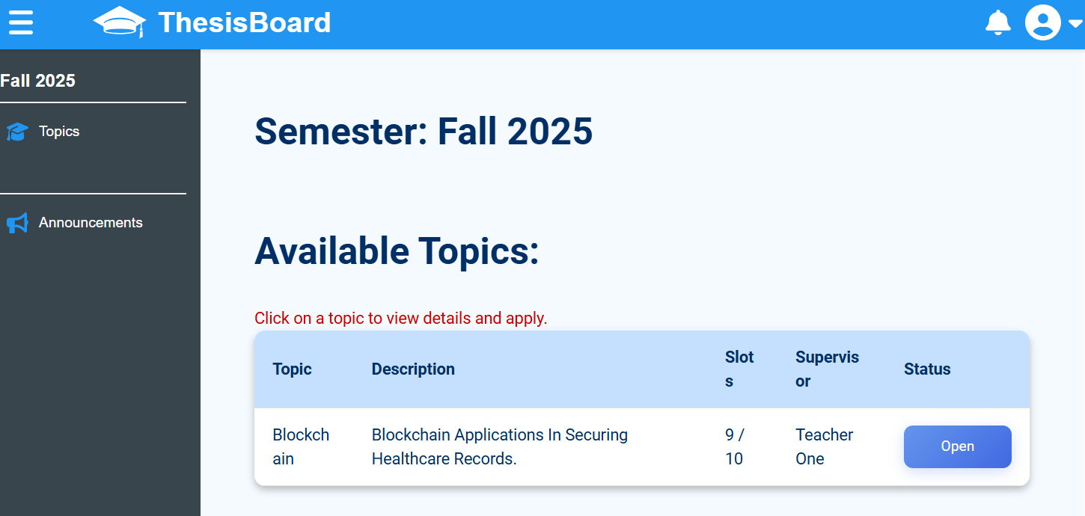
Figure 1. Pre-Thesis Topic List Page
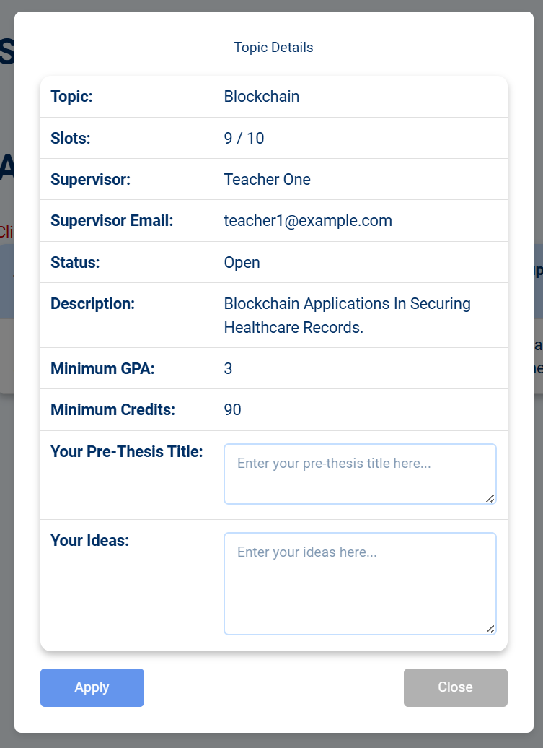
Figure 2. Pre-Thesis Registration

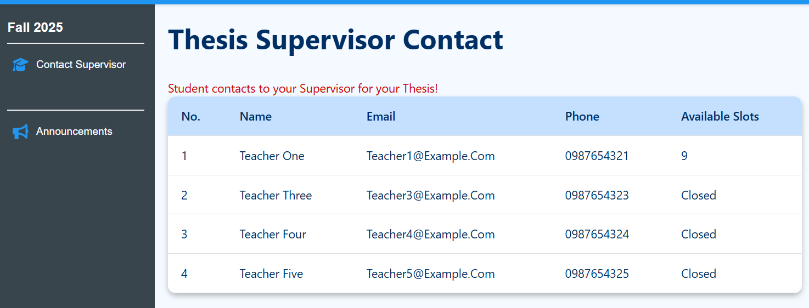
Figure 3. Thesis students contact teachers for registration
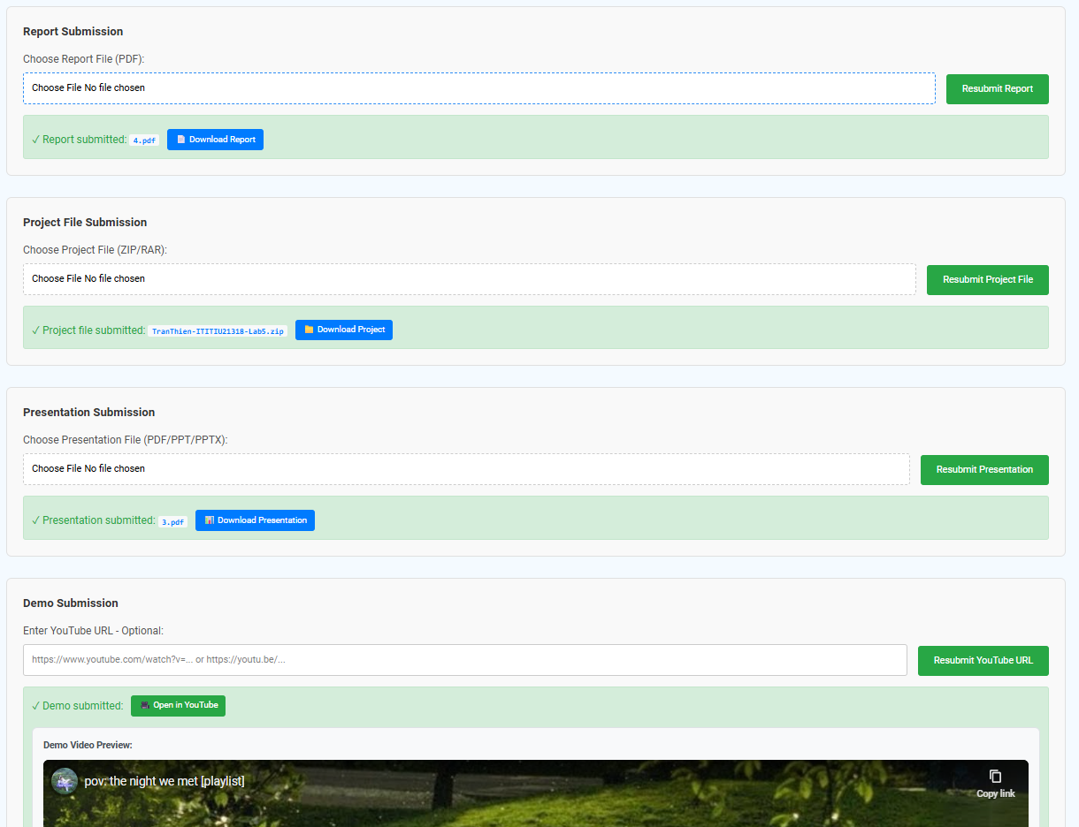
Figure 4. File submission form

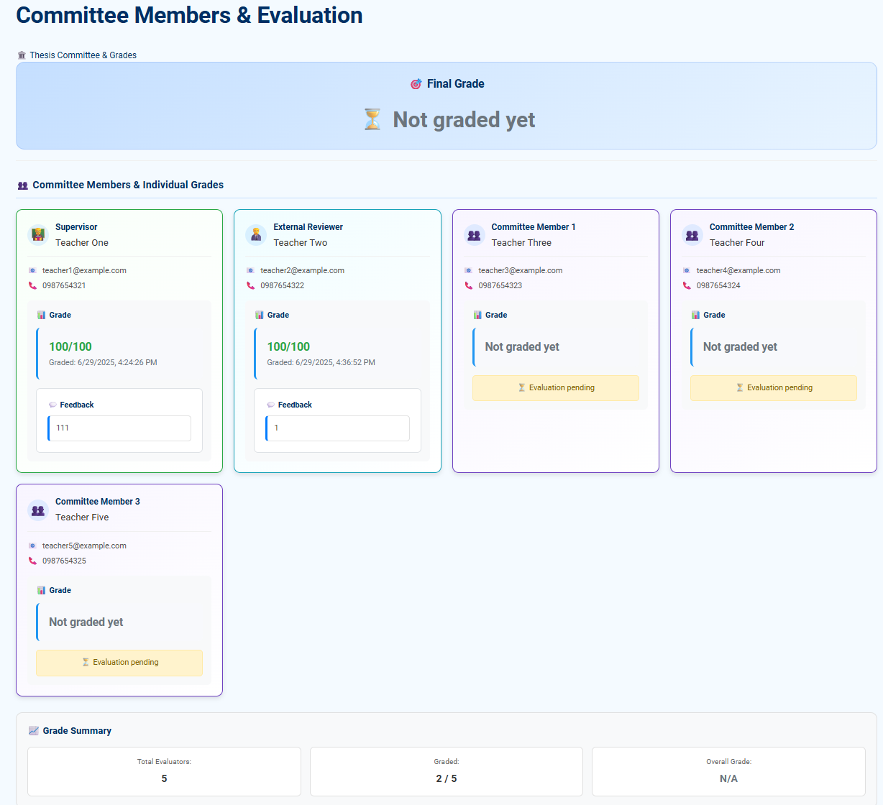
Figure 5. Grades and evaluation

- Teacher Functions
The system provides various features for educators to oversee activities related to both pre-thesis and thesis work. In managing pre-thesis activities, instructors can generate new topics by defining titles, descriptions, and available slots, and they can modify or delete these topics prior to the conclusion of the registration period. Through the student approval feature, lecturers are able to review applications and approve or reject students based on their eligibility. For thesis management, the process is more specialized lecturer contact information is made visible to students, and teachers can directly assign students in the system, as well as define or modify thesis topics and descriptions. The grading interface enables teachers to evaluate student submissions and provide feedback, with roles ranging from supervisors to reviewers or committee members. Additionally, lecturers can download project submissions for offline review and grading purposes.
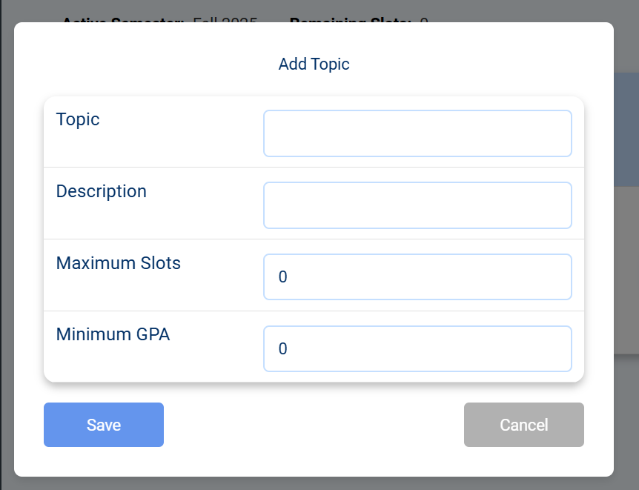
Figure 6: Topic creation form for pre-thesis
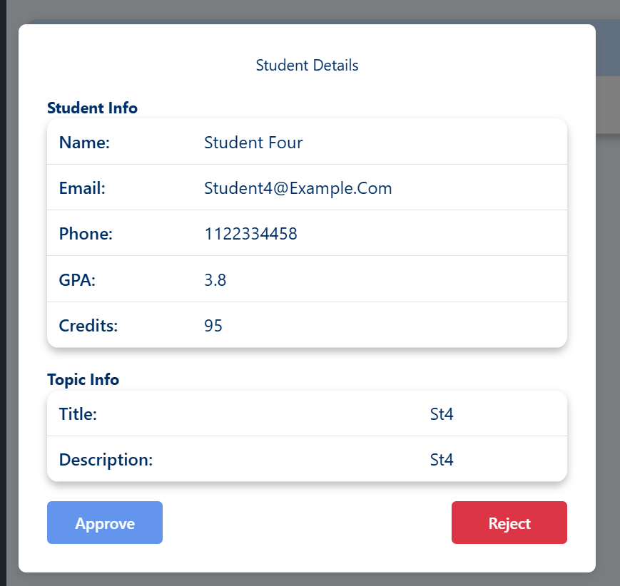  Figure 7. Student aproval table for pre-thesis | 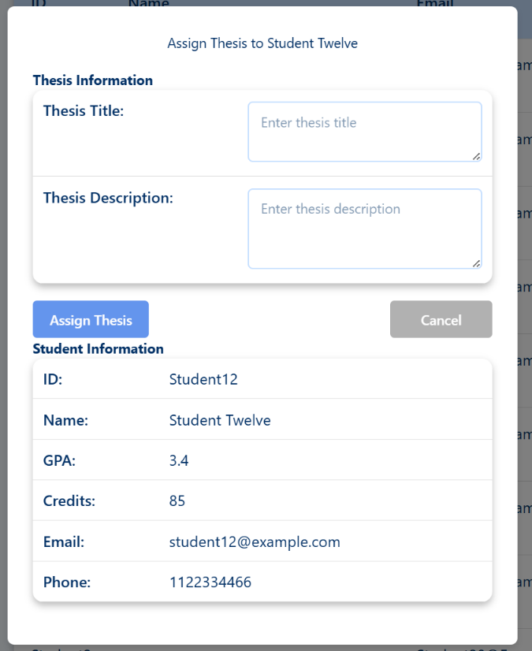  Figure 8. Thesis assignment form

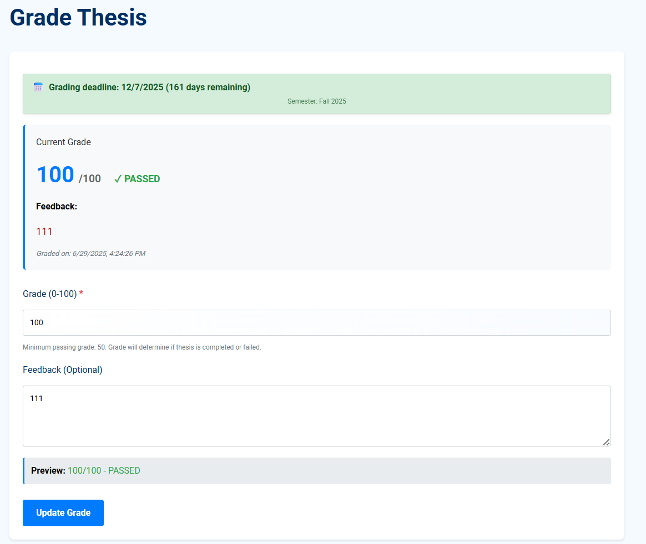
Figure 9. Grading form

- Moderator/Admin Functions
The platform equips moderators and administrators with essential management resources to efficiently oversee the thesis process. They can control deadlines by setting and adjusting significant dates for registration, submission, and grading phases. Through the reviewer and committee assignment function, they appoint appropriate faculty members to evaluate thesis students based on their availability and the relevance of the subjects. The system also facilitates report generation, offering overviews of topic registrations, grading metrics, and completion rates. Furthermore, moderators and administrators can send out announcements to notify all users about significant updates or reminders. Although both roles have comparable capabilities, administrators hold wider permissions, including the management of moderator accounts and, in future updates, the ability to access system data via statistical charts and audit logs. In summary, administrators maintain more extensive control over the entire system in comparison to moderators.
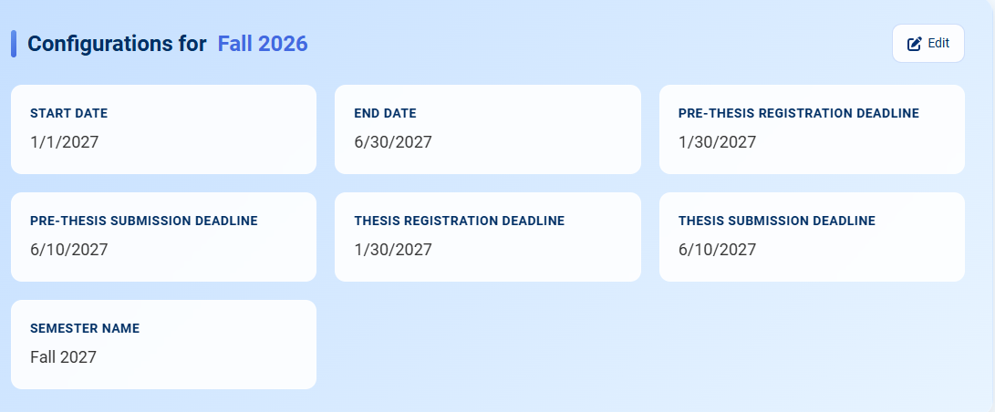
Figure 10. Deadline panel for semesters

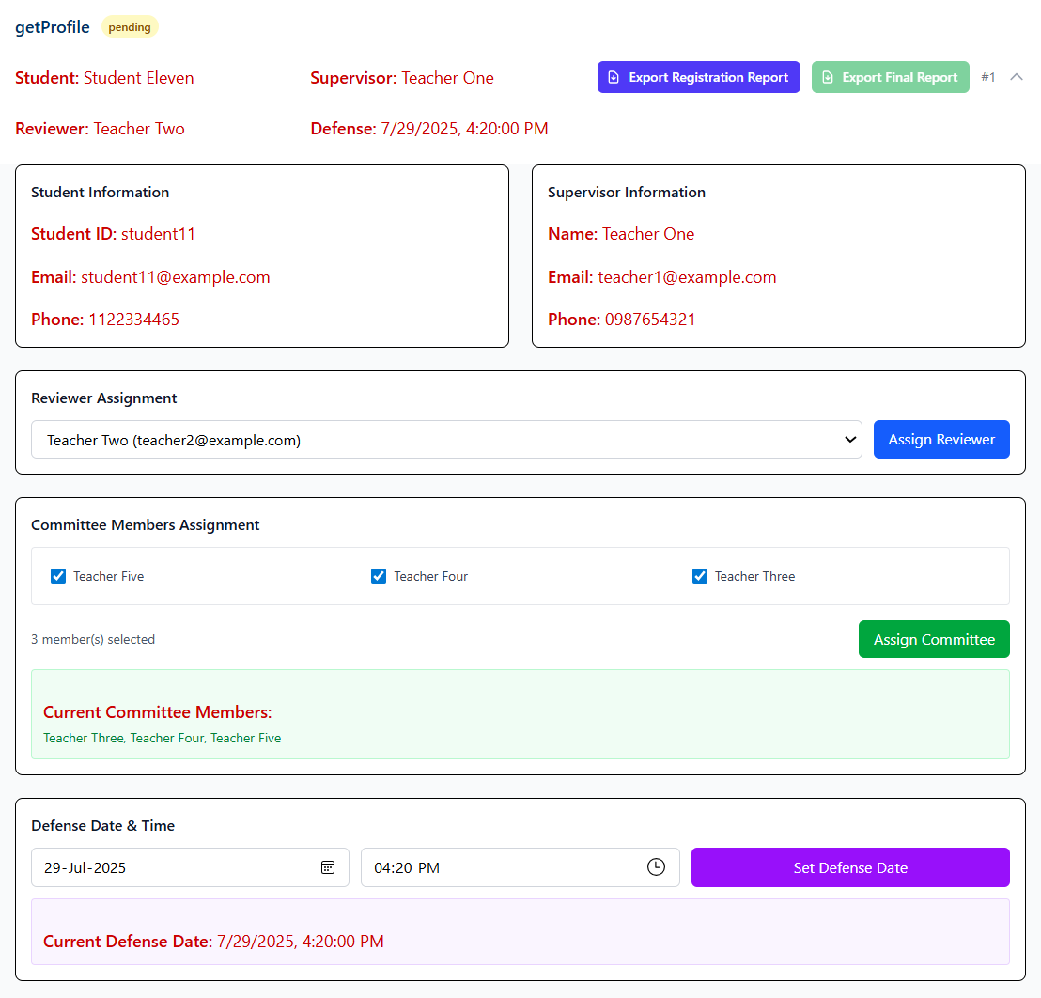
Figure 11. Thesis management

- Database Results
The backend of the system was developed using a hybrid database strategy, which integrates MySQL for core relational data management—such as information about users, topics, grades, and reports—while employing MongoDB to manage flexible, document-oriented data like announcements and system settings. The MySQL database comprises organized tables including Users, Topics, Registrations, Reports, Grades, Roles, and Deadlines, utilizing Sequelize ORM to effectively define and manage schemas and relationships. At the same time, MongoDB accommodates collections such as Announcements, Notifications, and SystemSettings.
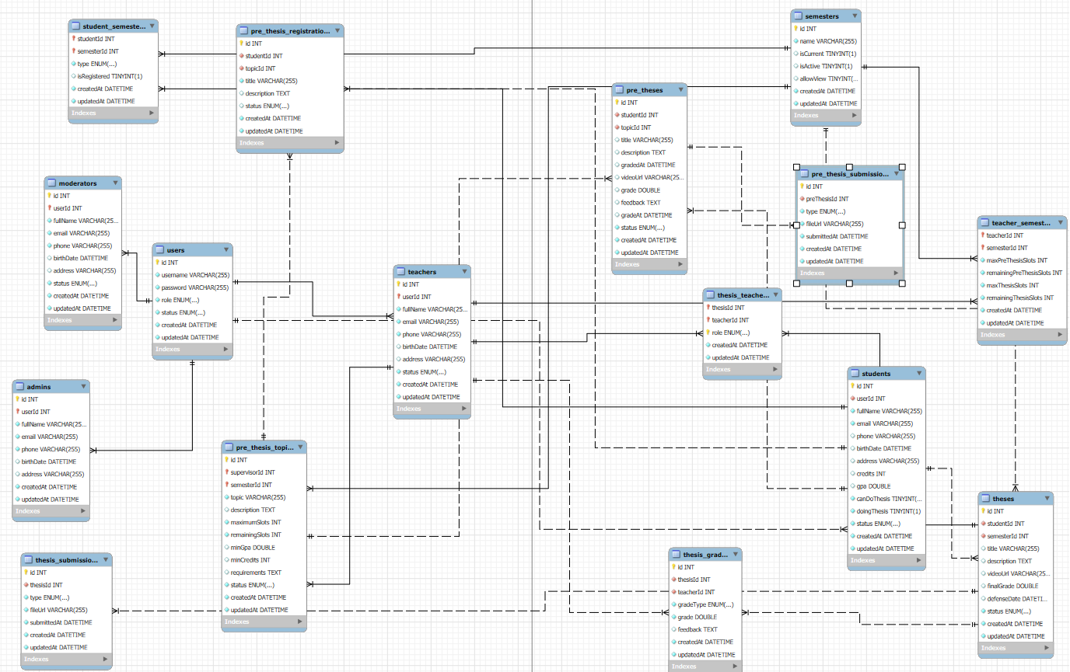
Figure 12. User ERD
- Summary
This chapter has outlined the functional outcomes of the implemented system for all user roles. The findings indicate that the system effectively facilitates the essential operations needed by the CSE department, which include registration, supervisor engagement, grading, and administrative management. The system interface is both responsive and sensitive to user roles, while the backend guarantees secure and organized data management. These findings affirm the success of the selected design and methodology.

CHAPTER IV

DISCUSSION / IMPLEMENTATION

- System Architecture
The system is designed using client-server architecture, following a Model-View-Controller (MVC) pattern. This design ensures a clear separation of concerns, modularity, and scalability. The client-side (frontend) is built using React, which manages the user interface and handles client interactions. The server-side (backend) is developed using Node.js with Express.js, which exposes RESTful APIs for frontend communication and handles business logic. The database layer includes a MySQL relational database for structured data and MongoDB for handling document-based configurations and announcements.
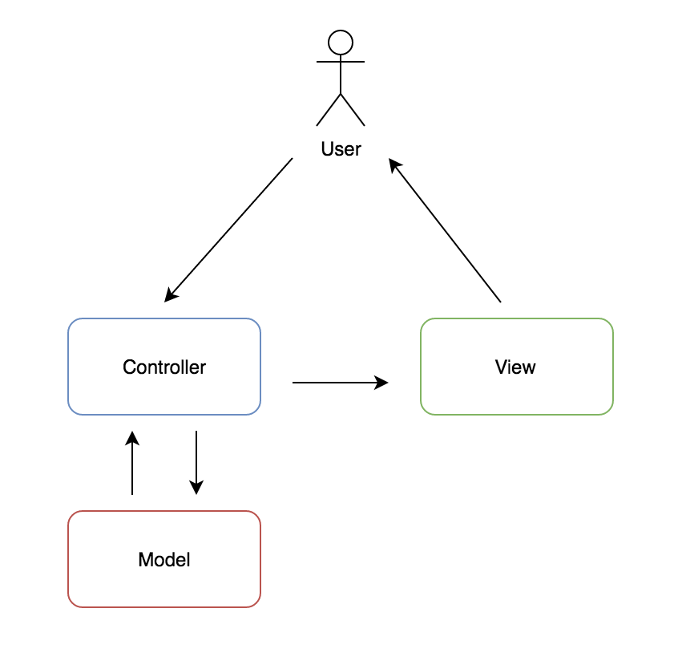
Figure 13. MVC model

- Implementation Tools and Environment
The website is designed by applying modern technologies. The frontend side uses React for dynamic control and UI effects is enhanced by CSS and a little tailwind CSS while the backend is implemented using Node.js with Express.js for routing. The databases are handled and structured in MySQL for user entities and MongoDB for unstructured data. GitHub is chosen as the repository of the whole project.

- Backend Implementation
The backend provides a secure and organized API for frontend communication. Key backend components include:
- API Structure:
  - RESTful endpoints organized under routes
- Authentication and Authorization:
  - JWT-based login system
  - Middleware for verifying roles (student, lecturer, admin, moderator)
- Routing with Express:
  - Modular route files for each resource
  - Express middleware for error handling and request validation
- Database Interactions:
  - Sequelize ORM is used to model tables such as Users, Topics, and Grades
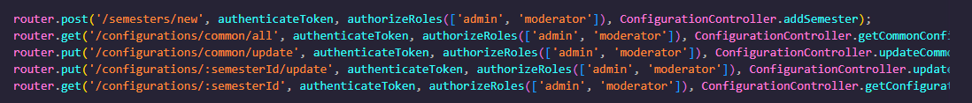
Figure 14. RESTful endpoints with middleware applied

- Frontend Implementation
The frontend was built using React and is fully component-based for reusability and clarity.
- Component Structure:
  - Components include TopicList, Dashboard, GradeForm, AnnouncementBoard, etc.
- Navigation:
  - React Router DOM handles routing between role-specific pages
- Form Handling:
  - Controlled forms for login, topic registration, grading, and announcements
- State Management:
  - React's built-in useState and useEffect manage state
  - LocalStorage used for tokens
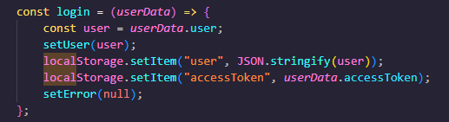Figure 15. AccessToken and user is stored in LocalStorage
- Role-Based Access Control
The system enforces strict role-based access both on the frontend and backend.
- Frontend:
  - Navigation and page access are restricted based on role (e.g., students cannot access grading pages).
- Backend:
  - Middleware checks JWT token and role before processing requests.
  - Unauthorized requests return a 403 Forbidden response.

- Integration of Frontend and Backend
The frontend and backend communicate via RESTful API calls using axios.
- CORS: Enabled on backend using cors middleware to allow frontend requests.
- Form Data Submission: Forms such as report upload and grading are submitted via POST or PUT requests with proper body parsing.
- Error Handling: Both backend and frontend implement error catching and display messages to users for common issues.

- Challenges and Solutions
Several challenges arose during implementation:
- Session Handling:
  - Resolved by using JWT stored in browser's LocalStorage
- Sequelize Relationships:
  - Initially complex to model topic-student-supervisor relationships; resolved with explicit foreign keys and join tables
- Asynchronous Operations:
  - Managed using async/await and proper error handling
- File Uploads:
  - Used multer middleware for handling file uploads, with secure file storage and size limits

- Summary
This chapter discussed the detailed implementation of the system, covering backend and frontend development, system integration, and access control. The development tools and technologies were used effectively to meet the system’s requirements. Despite a few technical challenges, appropriate solutions were applied to ensure a stable and functional platform. The next chapter concludes with the project and provides recommendations for future enhancements.

CHAPTER V

CONCLUSION AND RECOMMENDATION

This final chapter summarizes the overall work accomplished in the development of the thesis and pre-thesis management system. It highlights the key conclusions drawn from the project, outlines system limitations, and provides practical recommendations for future enhancements. The chapter also reflects on the project's long-term potential and concludes with a personal reflection on the development process.

- Summary of the Project
The system was developed in response to the lack of a structured platform for managing pre-thesis and thesis activities within the Computer Science and Engineering (CSE) department. Previously, these processes were handled through manual spreadsheets and email communication, leading to inefficiencies, delays, and lack of transparency.

The proposed web application aimed to streamline the workflow by providing dedicated functionalities for students, lecturers, moderators, and administrators. Major features include topic registration with eligibility checks, supervisor approval, report submission, multi-stage grading, and announcement broadcasting.
The development process followed the Waterfall model, starting with a comprehensive requirements analysis. This was followed by system design, where database schemas, UI layouts, and architecture were planned. The system was then implemented using modern web technologies, tested for functionality and stability, and prepared for demonstration and deployment.

- Major Findings and Achievements
The project achieved several key milestones:
- Functional Modules Delivered:
  - Student topic registration and report submission
  - Lecturer topic management and grading
  - Moderator deadline configuration and reviewer assignment
  - Admin-level system management
- Key Features Implemented:
  - Role-based access control
  - Automated slot validation and eligibility checks
  - RESTful API structure with secure authentication
  - Clean and responsive user interface using React
- Technologies Used Effectively:
  - Express.js and Sequelize for backend logic and data modeling
  - MySQL and MongoDB for hybrid data storage
  - GitHub for version control and team collaboration
All identified functional and non-functional requirements were addressed successfully, ensuring that the system is usable, secure, and stable.

- Limitations
Despite its functionality, the system has a few limitations:
- Limited analytics: The system lacks visual data reporting features for performance analysis.
- No email integration: Announcements and updates are only shown within the app interface; there is no notification via email.

- Recommendations for Improvement
Future improvements can further enhance the system’s value and usability:
- Advanced Admin Dashboard: Implement data visualizations, filtering tools, and performance indicators.
- Flexible Role Management: Provide customizable permissions beyond the default four roles.
- Conclusion
The thesis and pre-thesis management system successfully addresses a critical academic need by offering a centralized and structured platform for managing student research workflows. It replaces manual processes with an organized, role-driven interface that improves efficiency and transparency.
Beyond solving a real-world academic problem, the project also served as a valuable learning experience. It provided practical exposure to full-stack web development, database design, API development, and project planning. The skills gained throughout this project will contribute significantly to future academic and professional work.

REFERENCES

(n.d.). Thesis Management System. Creatrix Campus. https://www.creatrixcampus.com/thesis-management-system
(n.d.). Blackboard Learn for Students. BlackBoard. https://help.blackboard.com/fr-fr/Learn/Student
[FreeCodeCamp.org]. (2024, November 21). Learn React JS - Full Beginner’s Tutorial & Practice Projects [Video]. YouTube. https://www.youtube.com/watch?v=x4rFhThSX04&t=3089s

